Project Planning Phase

Project Planning Template (Product Backlog, Sprint Planning, Stories, Story points)

|  |  |
| --- | --- |
| Date | 09 November 2022 |
| Team ID | |  | | --- | | PNT2022TMID28596 | |
| Project Name | Natural Disaster Intensity Analysis and Classification using Artificial  Intelligence |
| Maximum Marks | 8 Marks |

**Product Backlog, Sprint Schedule, and Estimation (4 marks)**

|  |  |  |  |  |  |  |
| --- | --- | --- | --- | --- | --- | --- |
| **Sprint** | **Functional**  **Requirement (Epic)** | **User Story**  **Number** | **User Story / Task** | **Story**  **Points** | **Priority** | **Team Members** |
| Sprint-1 | Data Collection | USN-1 | As a user, I can collect the dataset from different images of cyclone, earthquake, wildfire and flood.. | 12 | Medium | Kaviyanjali.B  Keerthana.D  Akash.G |
| Sprint-1 | Data Pre-processing | USN-2 | As a user, I can load the dataset, scaling and split data into train and test. | 8 | High | Kaviyanjali.B  Keerthana.D |
| Sprint-2 | Model Building | USN-3 | As a user, I will get an application with ML model which provides high accuracy of images of cyclone, earthquake, wildfire and flood.. | 5 | High | Kaviyanjali.B  Keerthana.D  Ranjith S |
| Sprint-2 | Add CNN layers | USN-4 | Creating the model and adding the input, hidden, and output layers to it. | 4 | Medium | Kaviyanjali.B  Ranjith S |

|  |  |  |  |  |  |  |
| --- | --- | --- | --- | --- | --- | --- |
| **Sprint** | **Functional**  **Requirement (Epic)** | **User Story**  **Number** | **User Story / Task** | **Story**  **Points** | **Priority** | **Team Members** |
| Sprint-2 | Compiling the model | USN-5 | With both the training data defined and model defined, it's time to configure the learning process. | 4 | Medium | Ranjith S  Akash.G |
| Sprint-2 | Train & test the model | USN-6 | As a user, let us train our model with our image dataset. | 3 | High | Keerthana D  Akash G |
| Sprint-2 | Save the model | USN-7 | As a user, the model is saved & integrated with an android application or web application in order to predict something. | 4 | Low | Kaviyanjali.B  Keerthana.D  Akash.G  Ranjith S |
| Sprint-3 | Building UI Application | USN-8 | As a user, we access the camera to capture a live video, grab the video frames from the video by looping over the frames and convert the captured frame image from BGR to RGB. | 10 | Medium | Keerthana D  Ranjith S |
| Sprint-4 | Train the model on IBM | USN-10 | As a user, I train the model and integrate them on IBM. | 9 | High | Kaviyanjali.B  Keerthana.D  Ranjith S |
| Sprint-4 | Cloud Deployment | USN-11 | As a user, I can access the web application and make the use of the product from anywhere. | 11 | High | Kaviyanjali.B  Keerthana.D  Akash.G  Ranjith S |

# Project Tracker, Velocity & Burndown Chart: (4 Marks)

|  |  |  |  |  |  |  |  |  |
| --- | --- | --- | --- | --- | --- | --- | --- | --- |
| **Sprint** | **Total Story Points** | **Duration** | **Sprint Start Date** | **Sprint End (Planned)** | **Date** | **Story Points**  **Completed (as on Planned End Date)** | **Sprint Release (Actual)** | **Date** |
| **Sprint-1** | 20 | 5 Days | 24 Oct 2022 | 29 Oct 2022 |  | 20 | 10 Nov 2022 |  |
| **Sprint-2** | 20 | 5 Days | 31 Oct 2022 | 05 Nov 2022 |  | 20 | 10 Nov 2022 |  |
| **Sprint-3** | 20 | 5 Days | 07 Nov 2022 | 12 Nov 2022 |  | 20 | 10 Nov 2022 |  |
| **Sprint-4** | 20 | 5 Days | 14 Nov 2022 | 19 Nov 2022 |  | 20 | 12 Nov 2022 |  |

**Velocity:**

Imagine we have a 10-day sprint duration, and the velocity of the team is 20 (points per sprint). Let’s calculate the team’s average velocity (AV) per iteration unit (story points per day)

Average Velocity (AV) = 20/4 = 5

**Burndown Chart:**

A burn down chart is a graphical representation of work left to do versus time. It is often used in agile software development methodologies such as Scrum. However, burn down charts can be applied to any project containing measurable progress over time.

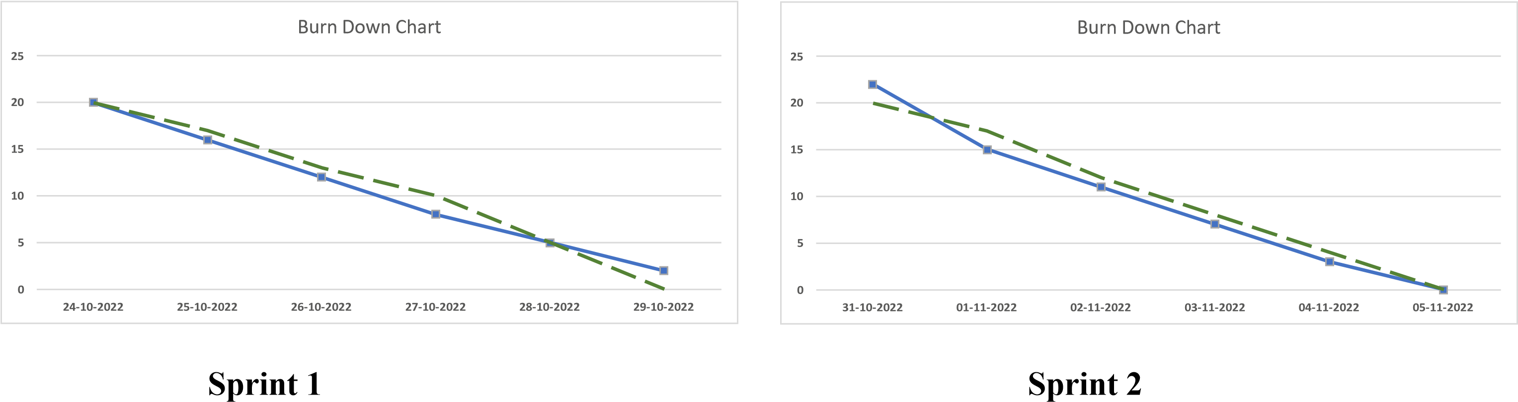



Burn

Down



**25**

**20**

**15**

**10**



**07**

**-**

**11**

**-**



**08**

**-**

**11**

**-**



**09**

**-**

**11**

**-**



**10**

**-**

**11**

**-**



**11**

**-**

**11**

**-**



**12**

**-**

**11**

**-**



Burn

Down

Chart



**25**

**20**

**15**

**10**



**14**

**-**

**11**

**-**

**2022**



**15**

**-**

**11**

**-**

**2022**



**16**

**-**

**11**

**-**

**2022**



**17**

**-**

**11**

**-**

**2022**



**18**

**-**

**11**

**-**

**2022**



**19**

**-**

**11**

**-**

**2022**

**Sprint 3 Sprint 4**

